**Exercise 1: Control Structures**

Scenario 1: The bank wants to apply a discount to loan interest rates for customers above 60 years old.

o Question: Write a PL/SQL block that loops through all customers, checks their age, and if they are above 60, apply a 1% discount to their current loan interest rates.

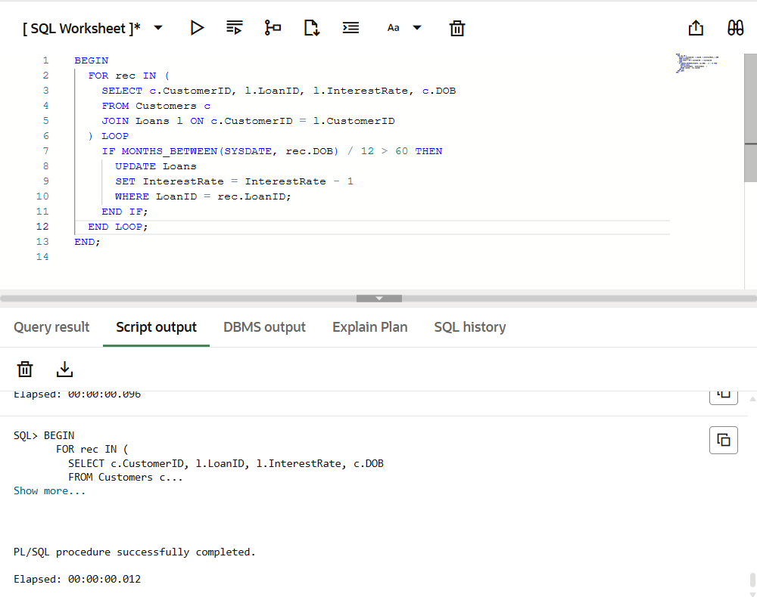

**Objective**  
Loop through all customers, calculate their age from DOB, and if they are older than 60, apply a 1%discount on their loan interest rate.

**Key Concepts**

* Looping over rows
* Age calculation using MONTHS_BETWEEN
* Conditional IF check
* UPDATE statement on Loans

Scenario 2: A customer can be promoted to VIP status based on their balance.

o Question: Write a PL/SQL block that iterates through all customers and sets a flag IsVIP to TRUE for those with a balance over $10,000.

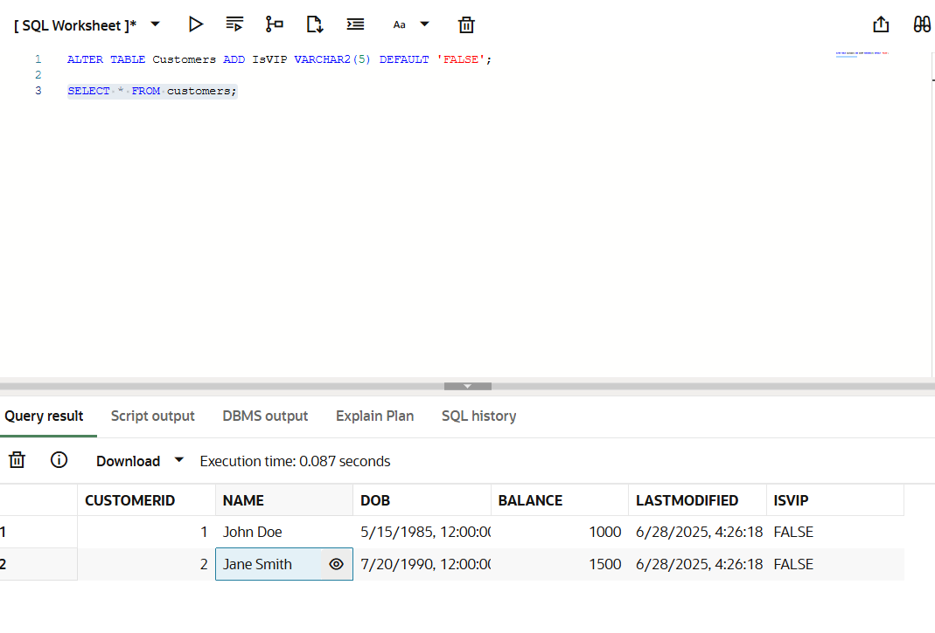

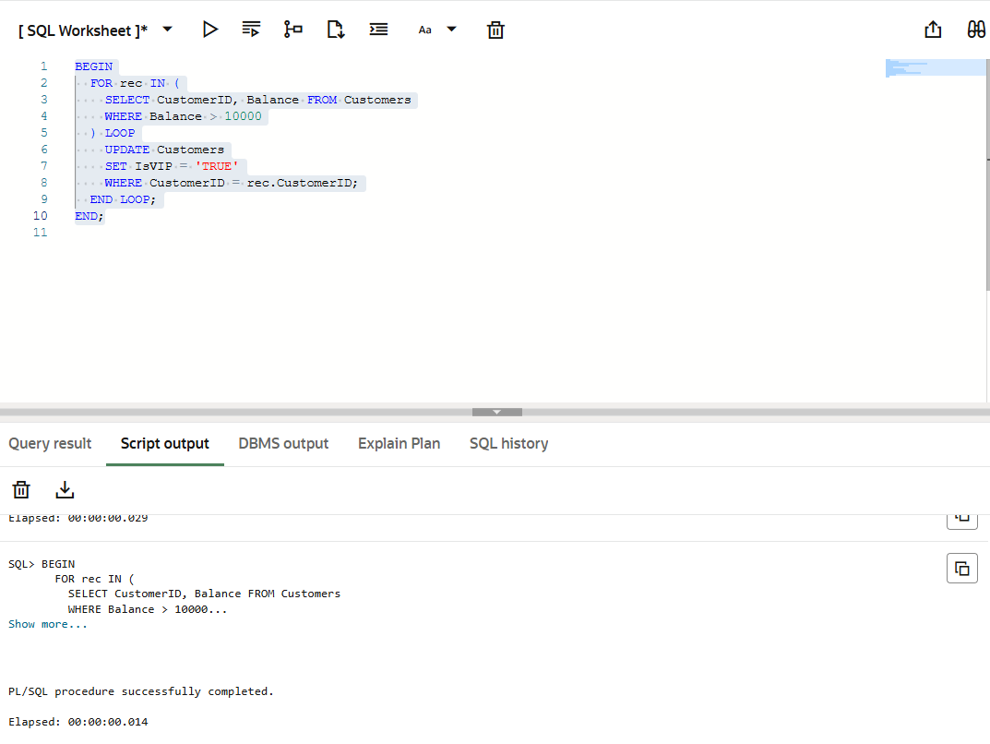

**Objective**:  
Iterate through all customers and set the IsVIP flag to 'TRUE' for those who have a balance greaterthan 10,000.

**Key Concepts**:

* Simple loop with condition
* Updating a single column based on a condition
* Optional use of default value ('FALSE') in altering table to avoid ELSE logic

Scenario 3: The bank wants to send reminders to customers whose loans are due within the next 30 days.

o Question: Write a PL/SQL block that fetches all loans due in the next 30 days and prints a reminder message for each customer.

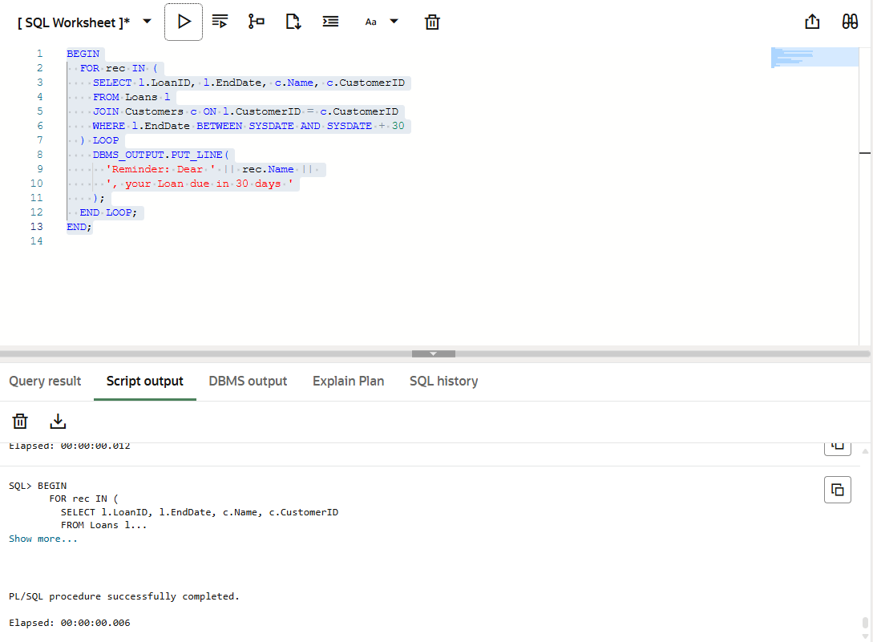

**Objective**:  
Fetch all loans whose EndDate is within the next 30 days, join with customer info, and print areminder message for each.

**Key Concepts**:

* Join between Loans and Customers
* Date comparison using SYSDATE + 30
* Looping through result set
* Output using DBMS_OUTPUT.PUT_LINE